Project Development Phase Delivery of Sprint – III

|  |  |
| --- | --- |
| Date | 3 November 2022 |
| Team ID | PNT2022TMID41904 |
| Project Name | IoT Based Safety Gadget for Child Safety Monitoring and Notification |

A6 GSM/GPRS MODULE

The module works to add both GSM features (voice call or SMS) and GPRS features. The advantages of these modules are the VCC and TTL serial level that have 5V voltage level. Module to accomplish almost anything a normal cell phone can; SMS text messages make or receive phone calls, connecting to internet through GPRS, TCP/IP, and more. To top it off, the module supports quad-band GSM/GPRS network.

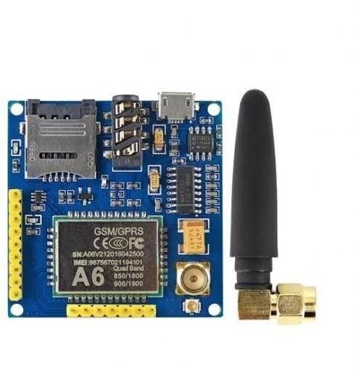

**Figure : A6**